WALKY
High Speed Swing Gate Opener

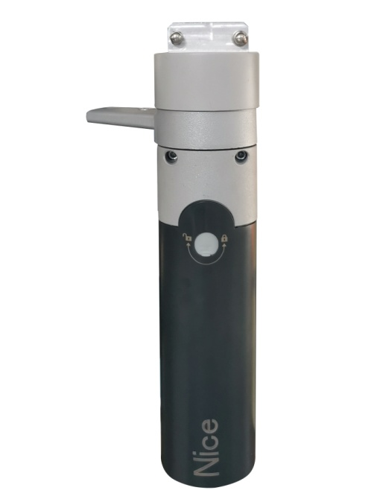

User's Manual

Notice

The distance between opener unit and control box needs to be within 20 meters in general.

Three cores cable：RVV3*0.5

Five cores shielding cable：RVVP5*0.5

室外定
Warnings

Please read this instruction manual carefully before the installation of door-automated system.
This manual is exclusively for qualified installation personnel. The manufacturer is not responsible for improper installation and failure to comply with local electrical and building regulations.

Keep all the components of door operator system and this manual for further consultation.

In this manual, please pay extra attention to the contents:
- Be aware of the hazards that may exist in the procedures of installation and operation of the door-automated system. Besides, the installation must be carried out in conformity with local standards and regulations.
- If the system is correctly installed and used following all the standards and regulations, it will ensure a high degree of safety.
- Make sure that the doors works properly before installing the door-automated system and confirm the doors are appropriate for the application.
- Do not let children operate or play with the door-automated system.
- Do not cross the path of the door-automated system when operating.
- Please keep all the control devices and any other pulse generator away from children to avoid the door-automated system being activated accidentally.
- Do not make any modifications to any components except that it is mentioned in this manual.
- Shut of power before connection, and the product must be earthed.
- If there is a failure that cannot be solved and is not mentioned in this manual, please contact qualified installation personnel.
- Do not use the door-automated system before all the procedures and instructions have been carried out and thoroughly read.
- Test the door-automated system weekly and have qualified installation personnel to check and maintain the system at least every 6-month.
- Install warning signs (if necessary) on the both sides of the door to warn the people in the area of potential hazards
Please read the instructions carefully before installing the product. Incorrect installation will cause danger.

Overview

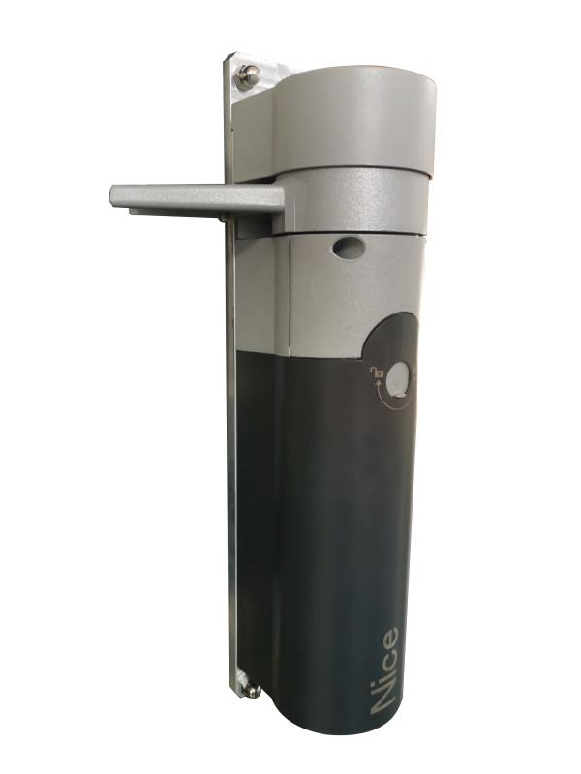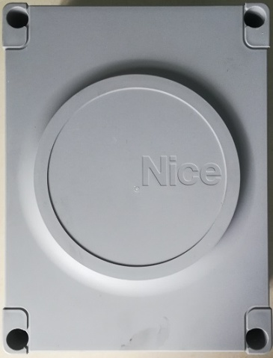

Technical parameters
Torque | 80Nm
Arm length | Short arm or long arm
Maximum gate width | 1.5m
Maximum gate weight | 100kg
Product weight | 13kg
Installation method | Out-Cell
Noise | ＜60dB
The lock  output | 12V,500mA
Door opening speed | 3-8S
residence time | 1-30S
Power Supply | 230V±10%，50Hz
Rated current | ＜1A
maximum power | 45W
standby power | ≤6W
Operating temperature | -40～85℃
Service life | Continuous operation 2 million times without fault
Degree of protection | IP55

Control box parameter table:
model | MPC-1100
Opening hours | 3-8 seconds adjustable
Open range | 45 ° - 135 ° adjustable
Electric lock output | DC12V:Normally open / normally closed contact
power supply | 230V±10%，50Hz
Rated current | ＜1A
Standby power | ≤6W
Maximum power | 45W
Operating temperature | -40℃-85℃

Installation process

Confirm the door opener
After receiving the goods, connect the opener and controller with wires and power on first please, to confirm the opener operation normal.
01.According to wiring diagram printed on the cover of control box, connect the door opener to the control box with eight wires.

Installation
1, Drill 4 mounting holes (φ9mm) and 1 cable hole (φ30mm) on door fram，install opener unit.

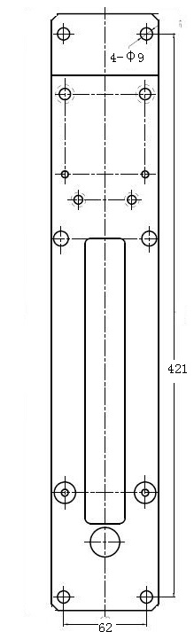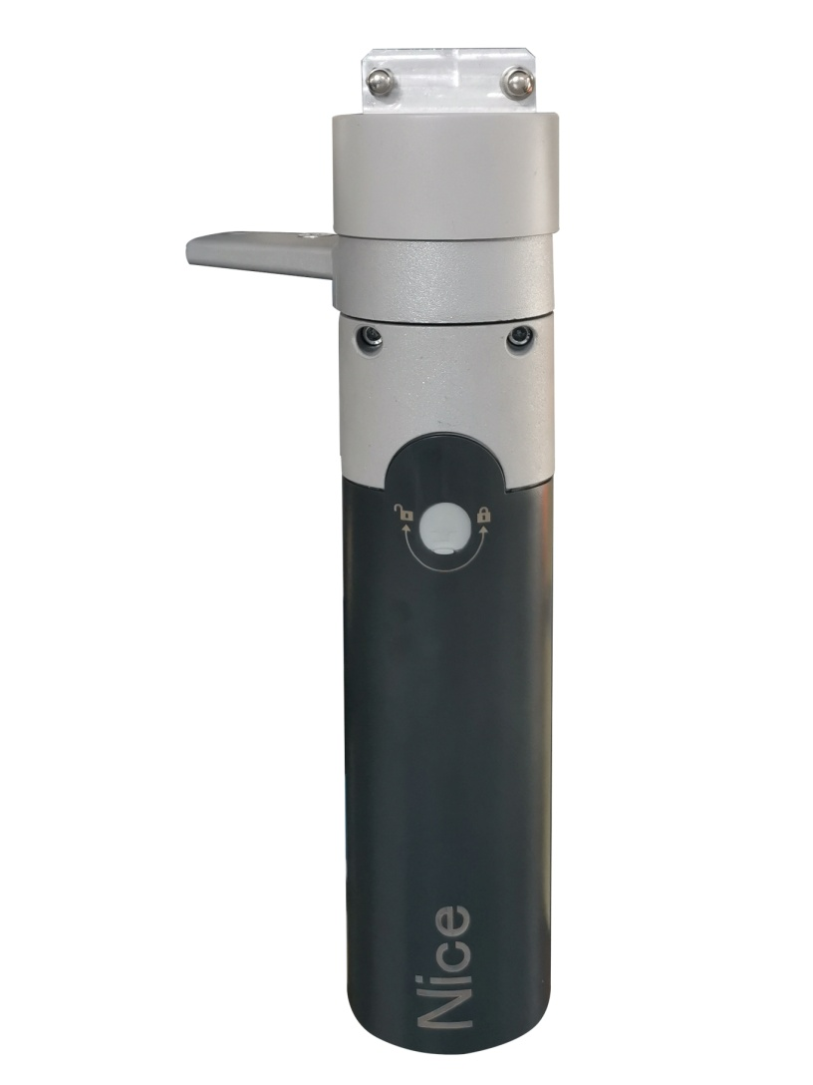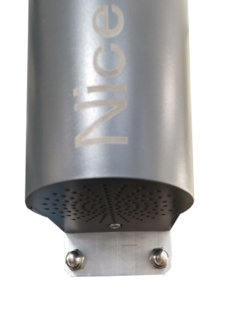
φ30
395

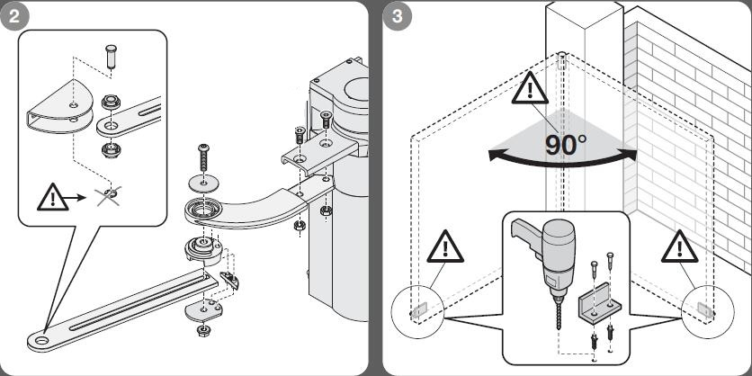
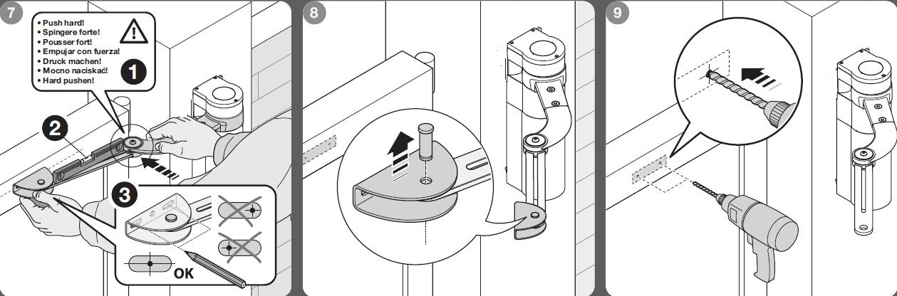
6
4
5
8
7
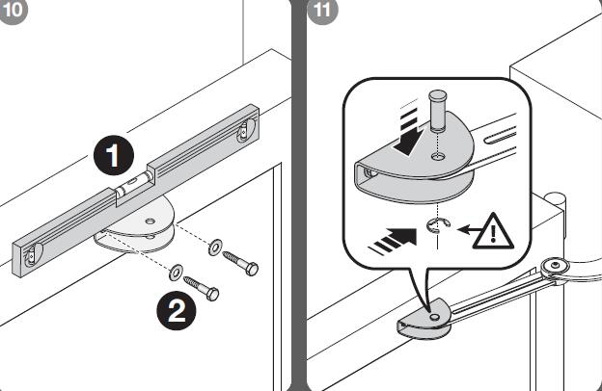
Commissioning process
Reset door opener ：Power off first, and then manually push the door to open about 45 °, power on the controller at this time.
If door running in close direction, it will stop automatically when the door closed in place, and reset completed.
If door running in open direction, adjust value in the parameter number 9 please.

The ports of Unit connection：

A、B、C terminal：The motor drive output terminals are respectively connected with the thick blue, white and yellow wires.

HA、HB、HC、+5V、GND terminal：as the signal input terminals respectively, white, yellow, blue and red, black five thin wires. It must use the shielded cable if transmission distance more than 5 meters and single-end earthed.

Note：3 cores motor cable and 5 cores signal cable must be separately layout to prevent mutual interference. The wires joint should be welded with tin and heat shrinkable tube, and do well waterproof treatment. In the installation process, it is forbidden to connect the 3 core motor wire with the 5 core signal wire.

Electric lock control ports：

1.L+：Lock the 12V output, then lock positive or self-locking

2.L-： Lock the 12V output, then lock negative or self-locking

3. (+12V/GND)： Power output interface, +12V output

The maximum output current is 500mA for magnetic lock and electric plug lock (unlock as power off), include E-lock and 12V power output.

Control signal input ports function：

(P1/GND)： Door open when signal input and the input signal is passive switching signal.

(P2/GND)：The forced close door signal input port, it is the highest priority. The input signal is the passive switching signal
(P3/GND)： Anti-pinch safe signal input port, input signal as passive switch signal.

(P4/GND)：Forbid any open signal input when door in closing. The input signal is the passive switching signal

Function of voltage signal input port：
EV+：The voltage signal is input to the positive port, and the input is 12V voltage signal

EV-：The voltage signal is input to the negative port, and the input is 12V voltage signal

Linkage port：

P5/GND：Bidirectional linkage port, needs double door synchronization open and close (normally open signal input)

P6/GND：Bidirectional linkage port, need double door synchronization open and close (turn off signal input)

The P5 and P6/GND terminals of the two controllers can be connected together to realize the double door linkage.

Controller wiring diagram
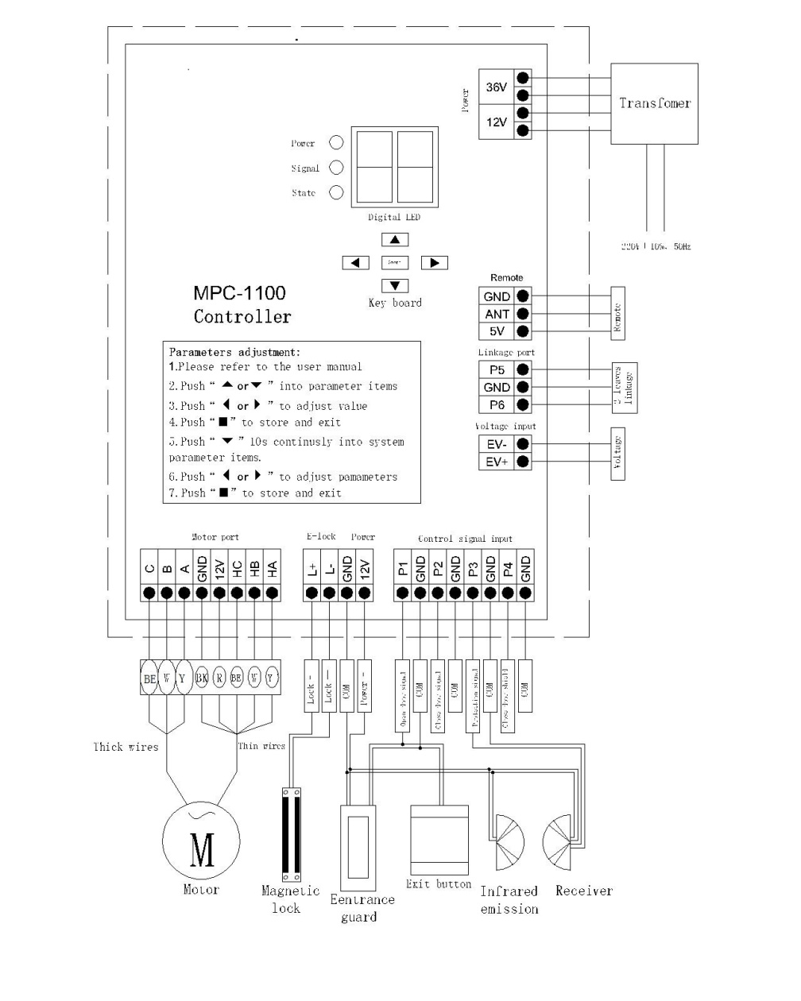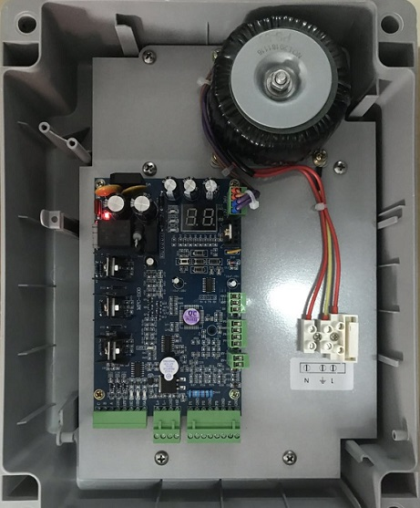

Keyboard function description
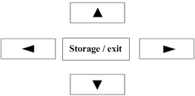

▲ | - Parameter number increment key, Enter parameter setting in standby state
▼ | Parameter number increment key
▲ | Parameter value decrease key
▼ | - Parameter value increment key
Storage / exit | Save the parameter after the settings are pressed

Parameter setting specification:
Press the ▲ key to enter the setting state, next to select the parameter number, then press the key to increase or decrease the parameter value to set.
Common parameter setting：
Parameter number | Functions | Value range | Factory value | Description
1 | Door opening speed | 0-30 | 25 | 0：The slowest；30：The fastest
2 | Door closing speed | 0-30 | 25 | 0：The slowest；30：The fastest
3 | Door opening angle | 0-99 | 49 | 0：Angle minimum；30：Angle maximum
4 | E-lock delay time | 0-99 | 0 | 0-1 Second
5 | Hold open time | 0-99 | 2 | 0：The open time is the shortest；99：The open time is the longest
6 | Anti-pinch sensitivity in closing | 0-30 | 0 | 0：The most sensitive；30： The most insensitive
7 | Press door strength | 0-10 | 5
8 | Mode selection： | 0-4 | 3 | 0：Push to close；1：Push to open；2：Two locks outdoor；3：Magnetic lock；4：Electric bolt lock
9 | Opening direction | 0-1 | 1 | 0：Left open；1：Right open
10
11 | Close slowdown distance | 0-50 | 27 | 0：The shortest；50：The longest
12 | Open slowdown distance | 0-50 | 31 | 0：The shortest；50：The longest
13 | Anti-pinch Sensitivity in opening | 0-30 | 15 | 0：The most sensitive；30： The most insensitive
14 | Speed in low-speed stage | 0-20 | 5
15 | Reset speed | 0-20 | 0 | The speed of door moves to close posision in reset stage
16 | EV signal mode | 0-1 | 0 | 0：Standard voltage input；1：Signal from E-lock both terminals.
17 | P1, P2 port function | 0-2 | 0 | 0：P1 auto, P2 close；1：P1 normal open, P2 close; 2: P1 inching open, inching close
18
19 | Controller mode | 0-1 | 1 | 0:Slave door mode; 1: Master door mode
20
21 | Restore factory setting | 0-10 | 0 | 0:Retain: 10：Restore factory setting
22

System parameter setting：

Parameter number | Functions | Value range | Factory value | Description
23 | Motor selection | 0-1 | 0 | 0：1000rpm；1：2000rpm
24
25 | Motor torque | 0-20 | 15 | 0：Maximum；20：Minimum
26 | Buzzer | 0-1 | 0 | 0: On；1：Off
27 | Application environment | 0-1 | 0 | 0：indoor；1：outdoor
28 | E-lock type | 0-1 | 0 | 0：Power on to lock；1：Power off to lock；
29 | 90°windproof mode | 0-1 | 0 | 0：Close；1：Windproof
30
31 | Remote function | 0-1 | 0 | 0：In common use 1：Switch to stop
32 | P5, P6 port function | 0-1 | 0 | 0：In common use 1：Switch to stop
33 | - Timing to close door | 0-1 | 1 | 0：Forbidden；1：Open, then 10 minuts to close.

Note:
Push down▼ key 10 seconds to enter the system parameter setting system, the factory has been set well, the user does not need to set up except in special circumstances.
Improper setting will cause unknown fault. If you need to set up, please consult the agent or our company

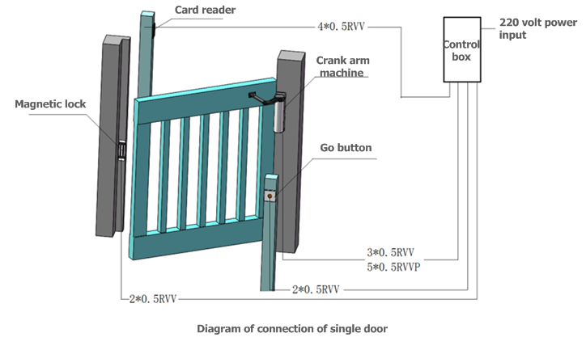

Trouble shooting
display | Explain | Processing mode
E0 | System error | Replace circuit board
E1 | Motor not connected | Check the terminal or reset the wire (focus five core line)
E2 | Motor or wire fault | Check the motor connection and replace the motor
E3 | Bidirectional port error | Check two machine linkage wire
E4 | 12V voltage is too high | Check the AC12V input
E5 | 12V voltage is too low | Check AC: 12V input; power lock status; 12V voltage port
E6 | 36V voltage is too high | Check the grid input voltage
E7 | 36V voltage is too low | Check AC36V input
E8 | The door body was not detected | Check the output shaft connection with the door, replace the unit
E9 | Closing obstacles | Check the door, hinge, remove obstacles
F1 | Motor not connected | Check the terminal or reset the wire (focus three core wire)
F3 | Model error | Check indoor and outdoor mode selection and motor connection wire
F4 | Double door is not detected | Check and adjust the door position, replacing the door lock

Warranty

Dealer:

